**FOGO SPRING 4 TESTING FEEDBACK- APP testing Not included**

**Site Access Link:**  
**Site**: <https://gofereatsfamily.trioangledemo.com/FOGO/public>  
**Admin**: <https://gofereatsfamily.trioangledemo.com/FOGO/public/admin>

**Admin Link:**

Username: admin

Password: gofergrocery

**Android App Link:**

<https://drive.google.com/drive/folders/1ITRJX-TwU4jjUqLys2ga6QziUM0qL5iO?usp=sharing>

**iOS App Link:**

store - <https://i.diawi.com/D1zSfW>  
Driver - <https://i.diawi.com/TVd9Ay>

**Video flow**:

<https://drive.google.com/drive/folders/1cXeG8rAeG1QNQERR0m654-qahO1h8rZC?usp=sharing>

**JIRA Tasks not complete/Changes needed-**

**FOGOW185-** Field details in JIRA are not included in wallet. Should include User ID, First name, last name, email, wallet amount. [FOGO (trioangledemo.com)](https://gofereatsfamily.trioangledemo.com/FOGO/public/admin/edit_wallet/160)

**FOGOW-186-** [FOGO (trioangledemo.com)](https://gofereatsfamily.trioangledemo.com/FOGO/public/user_payment) Wallet should be Markpro bold font and color, Just like “Promotions and Payments”

**FOGOW-189-** [FOGO (trioangledemo.com)](https://gofereatsfamily.trioangledemo.com/FOGO/public/checkout) Wallet amount should display next to the wallet check box. Please check the calculation on Wallet. Example- Jaclyn Mantilla has $140 in her wallet. She checks the wallet box on the order below and her wallet is displaying -$63.73. Calculation is not correct. She should have $77 left in her wallet. Balance should be $0.

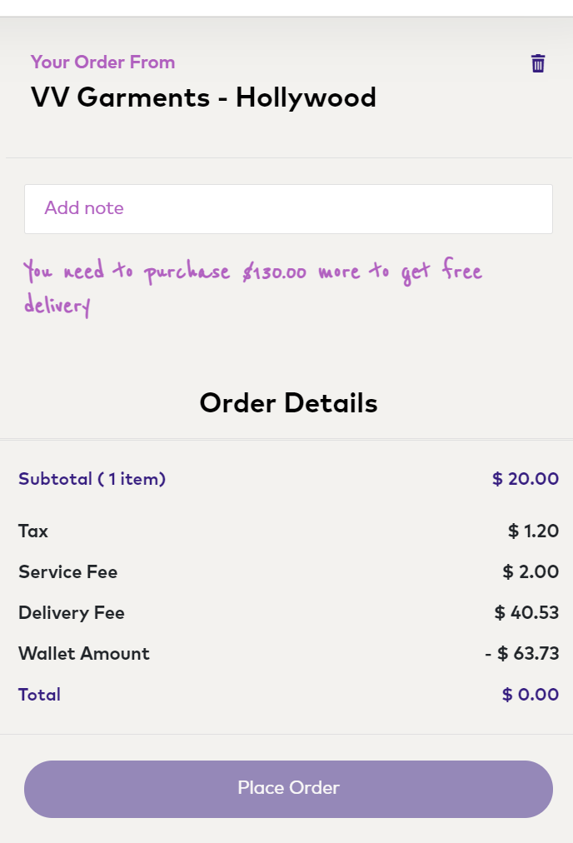

**FOGOW194-** [FOGO (trioangledemo.com)](https://gofereatsfamily.trioangledemo.com/FOGO/public/referel) Not complete- No referral code is showing. No Copy ICON is listed. The UI does not match FOGO coloring or fonts. Red Text below should be special situation font and color- Increase size of FONT Make it much larger. Text should read “Share**Referral code and get a $15.00 FOGO Credit for every referee that registers and makes a purchase.”** **Add the word “a” before $15. Remove the space between $ and 15**

Referral Code: - Should be MarkProBold font and color-

Actual code should be Mark pro black .

Headers in the Chart should be MarkPro Bold and color

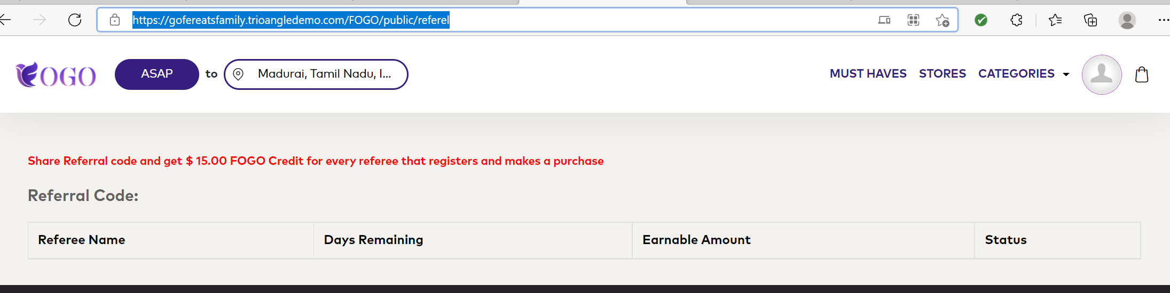

**FOGOW197,198**- Cannot test because I did not receive a referral code.

**FOGOW-207**- Driver payout: [FOGO (trioangledemo.com)](https://gofereatsfamily.trioangledemo.com/FOGO/public/admin/payout/2) There are search boxes on top for Dates but no dates in the data to search?

**FOGOW-209-** Date is not formatted correctly. Please see below, under “order confirmed” not sure why it is stating January -[FOGO (trioangledemo.com)](https://gofereatsfamily.trioangledemo.com/FOGO/public/order_track?order_id=1131)

* Note all fields are listing INDIA’s time, it should be EST

**FOGOW-228-** Shrink image that is uploaded- image size should look similar to the size formated in Must Haves- Images are displaying too big in list view.

**FOGOW-229**- Import data field example- Please use clothing as the example NOT Chicken. The form is not set up correctly for uploads. All sizes and colors should have their on line as they have their own upc. The cannot share a line for example- you have multiple sizes on one line “10 I 40”-

**FOGOW-233-** Add sort/filter feature to all headers of the assortment list like you have on the admin panel. i.e, option to sort categories etc.

Shrink image that is uploaded- image size should look similar to the size formated in Must Haves- Images are displaying too big in list view.

**FOGOW-234**- Import data field example- Please use clothing as the example NOT Chicken. The form is not set up correctly for uploads. All sizes and colors should have their on line as they have their own upc. They cannot share a line for example- you have multiple sizes on one line “10 I 40”-

**FOGOW-236**- Order details should be like checkout- Images and items details should be displayed. Invoice should include the list of the items, size , color and style purchased, just like checkout.. Not just the amount and quantity.

**FOGO-253- BUG**- After manual refund selected box popped up, I selected yes and got the following error page: [🧨 Trying to get property 'transaction_id' of non-object (trioangledemo.com)](https://gofereatsfamily.trioangledemo.com/FOGO/public/admin/admin_refund)

**FOGO- 256-** Cant test because bug link above.

**FOGO- 262,263,264,265-** How to test this?

**FOGO-267**- Changes don’t match image provided. Must have boxes should match sizes (specifications were given to Yuvaraj), the stores should be formated in a Square box not with round edges.

**FOGO-286-** [FOGO (trioangledemo.com)](https://gofereatsfamily.trioangledemo.com/FOGO/public/admin/delivery_time) Change time to be displayed in EST.

**FOGOW-293-** Item ID number should be black and Not bolded. ID should only display when you click on an item detail page, not on icon page.

* **FOGOW-295-** Auto renewal message- Change special situation font to be the correct color- Change”!” to be FOGO Purple shade.

* [FOGO (trioangledemo.com)](https://gofereatsfamily.trioangledemo.com/FOGO/public/subscription_history) Subscription history and auto renewal is not displaying correctly. I had a monthly subscription and changed it to another subscription- Auto renewal should of automatically changed to off on the current subscription. The effective and end dates should list on subscription history- They do not… (see below).

**FOGOW-297-** Jaclyn’s closet is closed on Sunday- When searching in Hollywood the store is not feeding to site. [FOGO (trioangledemo.com)](https://gofereatsfamily.trioangledemo.com/FOGO/public/store)

**APP FEEDBACK – BASED OFF OF FINAL Development video:- Need updated links to test myself**

1. App- Image add to orders- The image is not displayed correctly- It should show the whole image and not cut it off. Please ensure image auto fits to display correctly in the box. This seems to be an issue across all platforms.

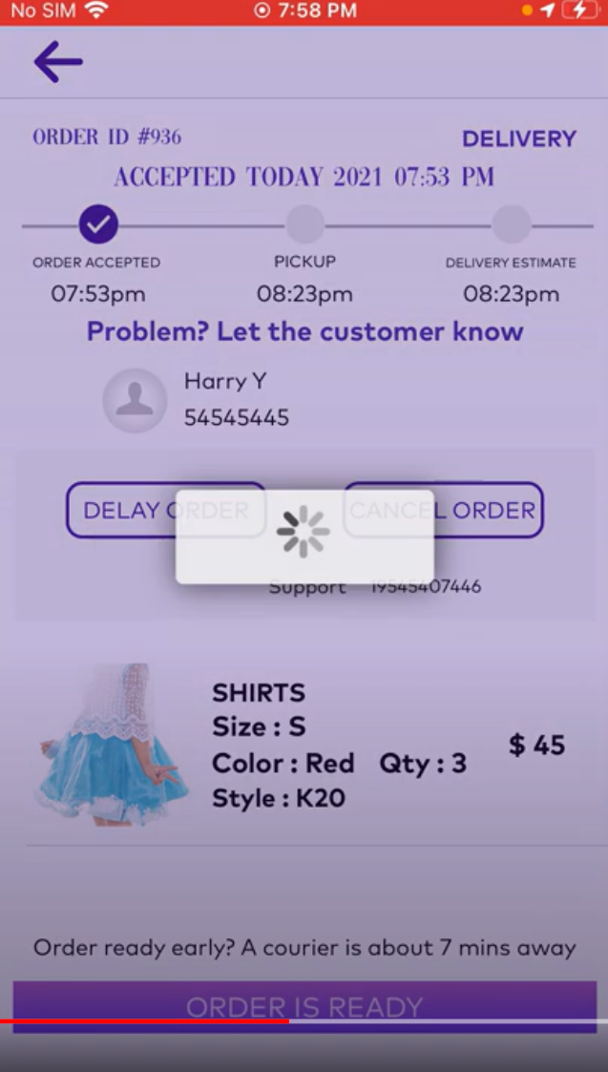

1. Delivery image –IOS- Please replace the current image of an ID, with something like a delivery drop off image.. an ID is confusing. Stick to our color theme.

Android app looks different, these should looke the same..

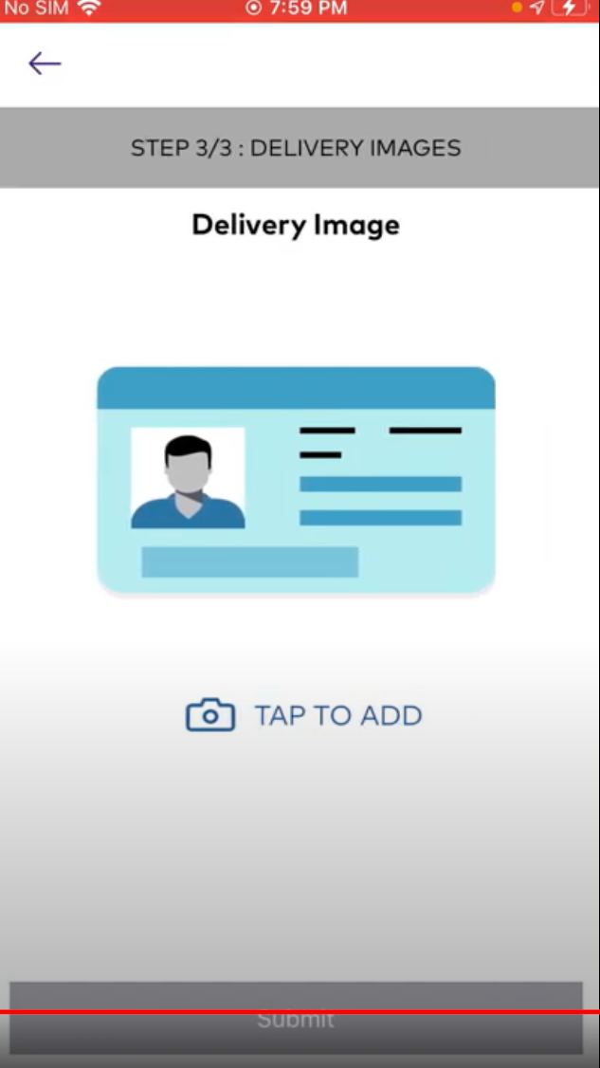

**TESTING FEEDBACK**

* [FOGO (trioangledemo.com)](https://gofereatsfamily.trioangledemo.com/FOGO/public/stores)- Under search category there are two lines “Top Categories, More Categories” These are not clickable… What do these do?

Search for store or Cuisine is the text that appears… It should be search for store or category..

* 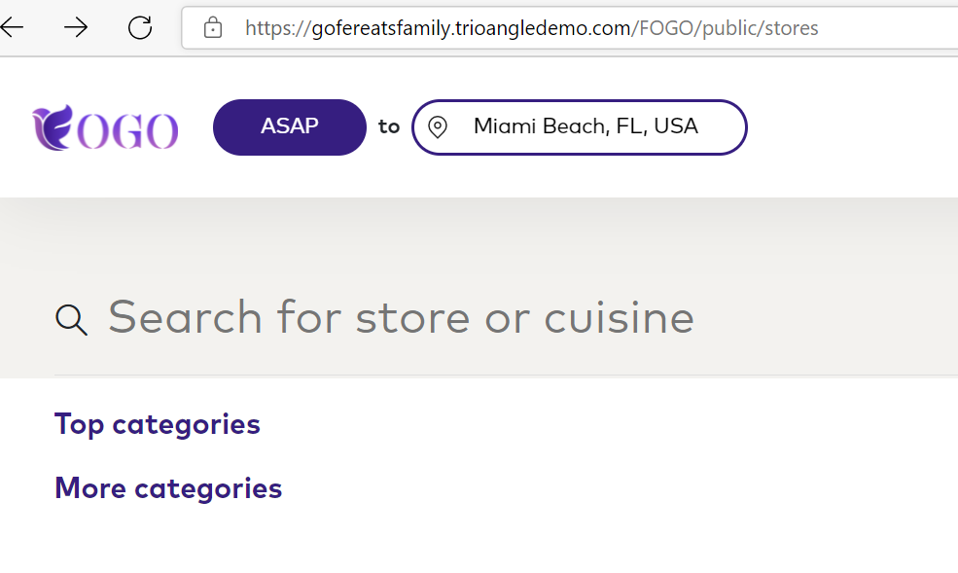

[FOGO (trioangledemo.com)](https://gofereatsfamily.trioangledemo.com/FOGO/public/stores?service_type=1)- Top box for address on this page isn’t calculating. Example- I type in Miami, FL.. the address should auto populate and pull all stores in 100 miles and it is not. You have to hit the refresh bar on top and it goes back to old addressed typed in.

**Note-** Admin panel settings for distance is 100 Miles for store and driver.. Stores are not feeding. Only VV garments and Mcdonald stores are feeding when I type in areas in Miami and Hollywood.. There are more stores such as Jaclyns closet that should feed.

* [FOGO (trioangledemo.com)](https://gofereatsfamily.trioangledemo.com/FOGO/public/stores) No stores feeding under popular stores near you, but must haves are showing and when you click on stores 2 stores are showing.

* I placed an order that was not confirmed by the store. The order disappeared from my pending order page. What notification do we give customers that their order is cancelled?

Order still exists in the order management page as pending: [FOGO (trioangledemo.com)](https://gofereatsfamily.trioangledemo.com/FOGO/public/admin/view_order/1131) - Please advise what the process should be on this..

* [FOGO (trioangledemo.com)](https://gofereatsfamily.trioangledemo.com/FOGO/public/category)- BUG items should not feed to the site once they are sold out. When I shop under categories items are listed that are sold out- example, Ruffle top 1234. When I click on the item it takes me to an empty store (Resta). When I shop stores this store (Resta) is not listed as an option. [FOGO (trioangledemo.com)](https://gofereatsfamily.trioangledemo.com/FOGO/public/store)
* [FOGO (trioangledemo.com)](https://gofereatsfamily.trioangledemo.com/FOGO/public/admin/add_category) Category management- Remove mandatory field off of description and image of category.
* [FOGO (trioangledemo.com)](https://gofereatsfamily.trioangledemo.com/FOGO/public/stores)- Center text ie-store name, price and time under the store.
* [FOGO (trioangledemo.com)](https://gofereatsfamily.trioangledemo.com/FOGO/public/admin/view_driver)- Times listed on dashboard should be displayed as EST.
* Color swatches are not displayed correctly on user page.- The primary image should pull from the first **front** image loaded. The color image should show as a swatch- See reference below.

* **UI- Item image display-** Item image should display the same way throughout the shopping experience. Example below at checkout the little girls head is cropped out in the image.. It is not displayed thatway when shopping under stores. Need to update images so they display evenly throughout the entire shopping experience.

* Refund- Order Id- Where can I see the image of what the item is they purchased? On the store app under order history?
* Update special sittuation font color to match brand guide line.

* Color Tan in item below has 8 units in stock vs. Threshold of 7. I am trying to buy 1 units and this is the error. System should let me buy up until threshold. Error message does not make sense. Note- Color black was the same units 8 vs. Threshold of 7 and I did not get this error message.

[FOGO (trioangledemo.com)](https://gofereatsfamily.trioangledemo.com/FOGO/public/details/12)

* [FOGO (trioangledemo.com)](https://gofereatsfamily.trioangledemo.com/FOGO/public/musthave)- Must haves are not feeding correctly. Must haves filter by shopping address just like stores and categories. I was shopping in Hollywood Fl and noticed a store from india was feeding to must haves during check out. I received ORDER ERROR MESSAGE- “Store location unavailable” would not let me check out.. Store “Shanmuga textiles” located in india showed under my search in Hollywood FL.
* Color tan is showing sold out on the website- When you go in to category management the color exceeds the threshold and should be available for purchase. [FOGO (trioangledemo.com)](https://gofereatsfamily.trioangledemo.com/FOGO/public/details/12?item_id=376), [FOGO (trioangledemo.com)](https://gofereatsfamily.trioangledemo.com/FOGO/public/admin/menu/71)

* [FOGO (trioangledemo.com)](https://gofereatsfamily.trioangledemo.com/FOGO/public/stores?q=Beauty) Search bar does not work- I tried typing Dresses, Jeans, Tops it does not take you to these categories.
* User on Mobile Web-You cannot access profile, Past orders etc. I am clicking on the avatar image to access, and it does not take you anywhere.

* App Icon- Make size of F larger on IOS and Android icons, reference below.

**YUVARAJ WOULD LIKE TO DISCUSS THE BELOW POINTS- SCHEDUALE A CALL-**

Would like to be walked through the payout process for stores and Drivers- I don’t understand per the below.

* [FOGO (trioangledemo.com)](https://gofereatsfamily.trioangledemo.com/FOGO/public/admin/per_day_report/153/13-09-2021/19-09-2021)- Need to understand Driver Payout process- Please explain this screen and the email.
* 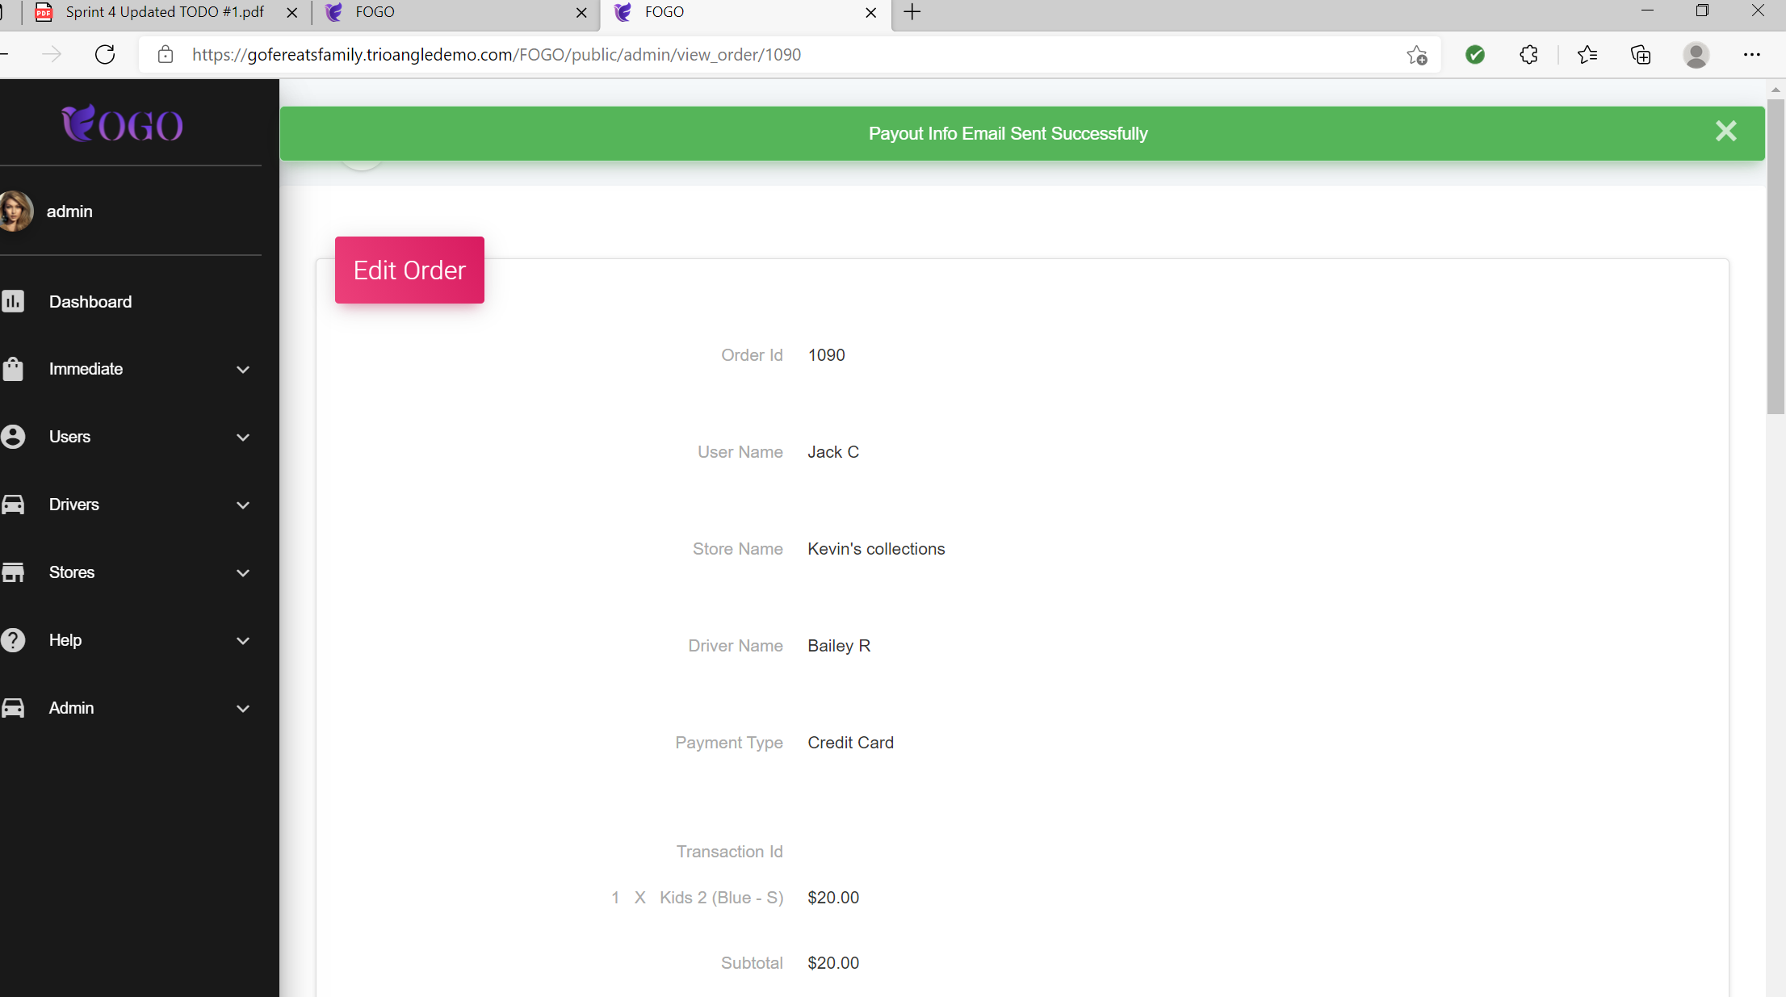
* How Does stores payout method on their dashboard link to payout..
* How do auto renewal of payments match up to subscription center?
* If the store accepts the order then delays it Is there a reminder after a while that they still have an order pending?
* When a store cancels an order how is the user notified? I cancelled an order and did not receive an update?
* When an order is on its way or been delivered to a user how are they notified?
* [FOGO (trioangledemo.com)](https://gofereatsfamily.trioangledemo.com/FOGO/public/stores?q=Jeans%20pant) When you search for a category on top nav- Top categories is listed- how does it pull Top categories?
* **If an order is placed with multiple items in the cart and a store only confirms 2 of the 4 items will the order still go through and update billing?**